**Description**

**You are a cyber security officer and member of the Incident Response Team.**

**During the summer vacation, one of the teaching staff members, Samantha, reports to the Dean about abusive and threatening messages received over an email. Dean collects the following details from her:**

**Complete Name: Samantha R. Collen.**

**Personal Email ID: samantha.collen.r@gmail.com**

**Official Email ID: profsamantha@pu.edu.com**

**Samantha also reported that during the term examination, she obstructed one of the students, Tony Lee, due to unfair means during examination.**

Case investigated and report compiled by: SRIJAN(srijanspl2017@gmail.com)

| UNIVERSITY CYBER ATTACK |
| --- |
| Complete incident report |
| Incident report of cyber attack on a university staff member. |

TASK 1: Obtain a scanning report of the entire network and identify how many terminals are connected with the Windows operating system and the Linux-based systems.

To identify all the system within the university network and examine their vulnerabilities:

**A. Scan the server terminal for IP address and MAC address using the following command:**

**$ ip addr**

The screenshot of the output is given below:

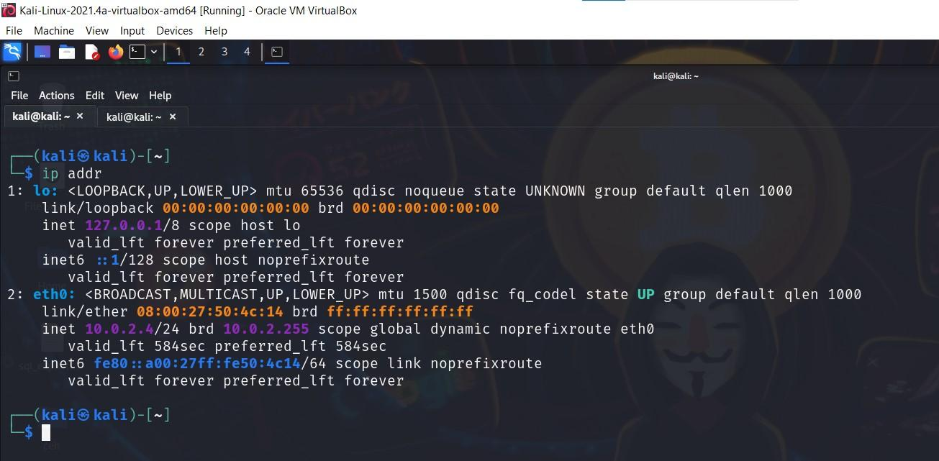

**B.** Run NET DISCOVER and nmap –sn –PE –PR <target network range> command for identifying all connected and active terminals with the server.

**$ netdiscover –r 10.0.2.0/24**

As the server IP is 10.0.2.4, with a CIDR of 24

The screenshot of the output is given below:

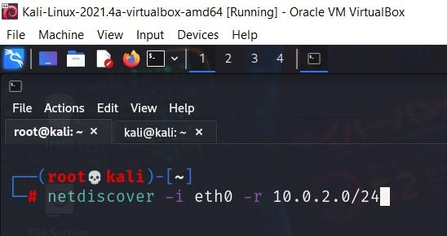

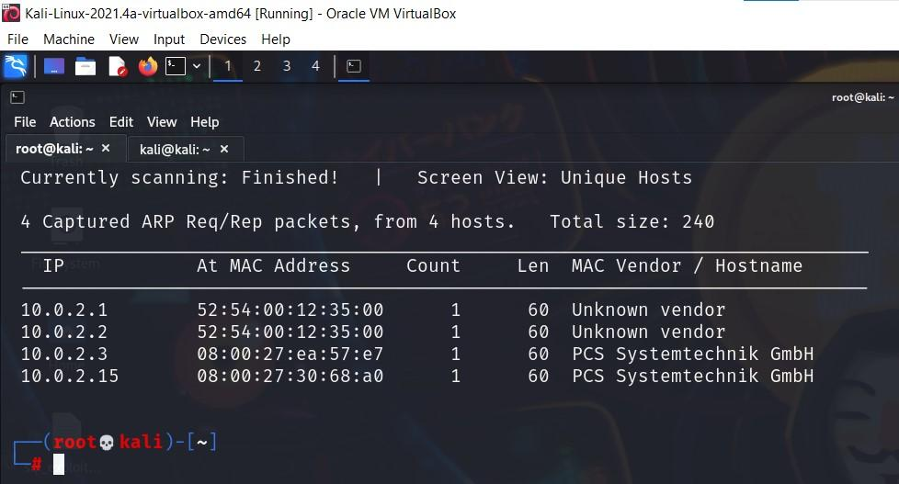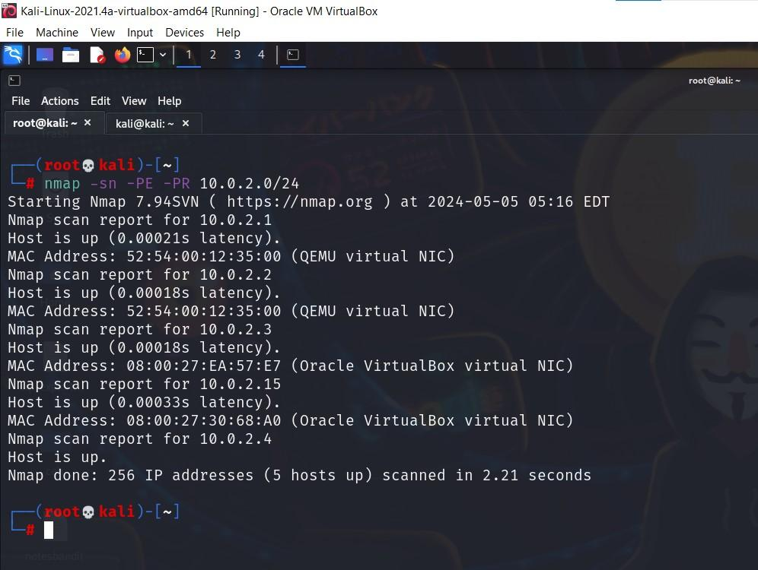

Through above commands we have discovered the complete network topology with each nodes IP and MAC address and hence the following conclusion:

Default gateway of network is **10.0.2.2**

IP address of victim machine is **10.0.2.15**

Default IP of router is **10.0.2.1**

**C.** Check communication between server and victim machine using the PING command.

**$ping –c 4 –I eth0 10.0.2.15**

By analyzing the TTL value, it can be easy to identify the type of operating system connected in networks.

TTL values corresponding to different operating systems are:

TTL 128, 63, 64, 40-55 are respective to Windows machines, Linux machines, Mac machines and firewalls.

The screenshot of the output is given below:

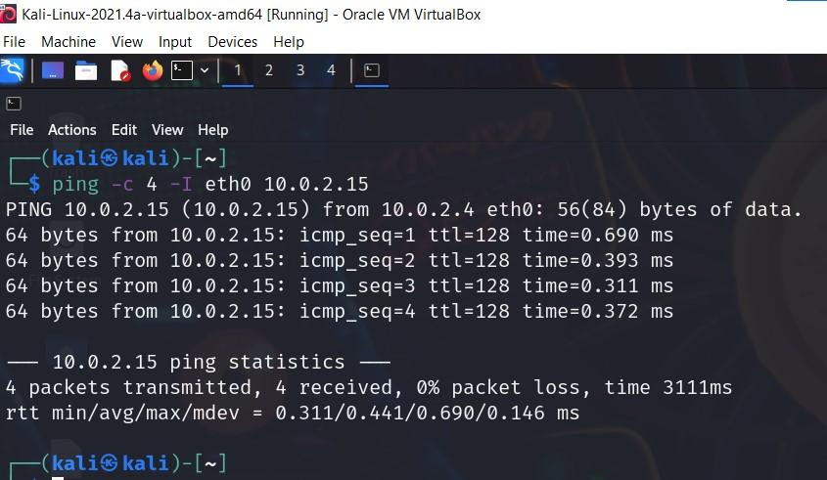

**Summary:**

* Server IP is **10.0.2.4**
* Victim IP is **10.0.2.15**
* **Total 1 terminal is connected with the server and the type of operating system is Windows.**

TASK 2: Identify CVE score of the victim’s vulnerability

Since we have retrieved relevant information about the network environment and connected machines, it’s time to perform an autopsy of the victim’s machine.

Vulnerability search is about scanning the target device for all the open ports and associated services and checking them against the NVD to determine if any CVE exists.

**A.** Use NMAP command and analyze available ports information

**B.** Once you receive the port information, check the type of vulnerability with the CVE score portal of the NVD.

**Commands:**

**$ nmap –Pn –sT –sV –O –p- -T 5 <target IP>**

The screenshot of the output is given below:

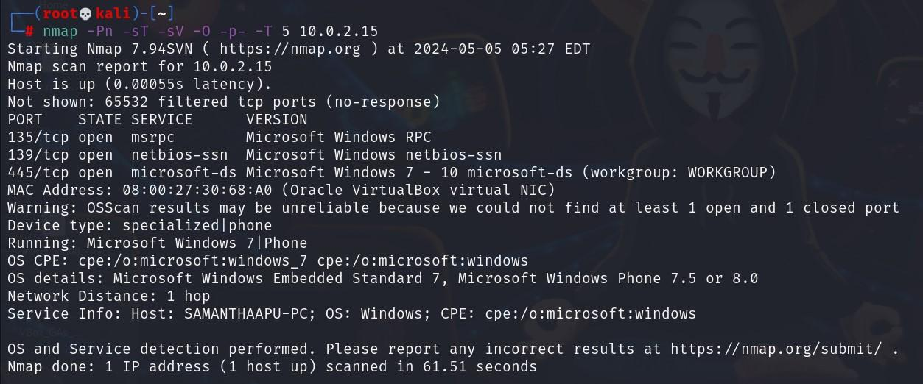

Check the CVE score for all services and there versions*

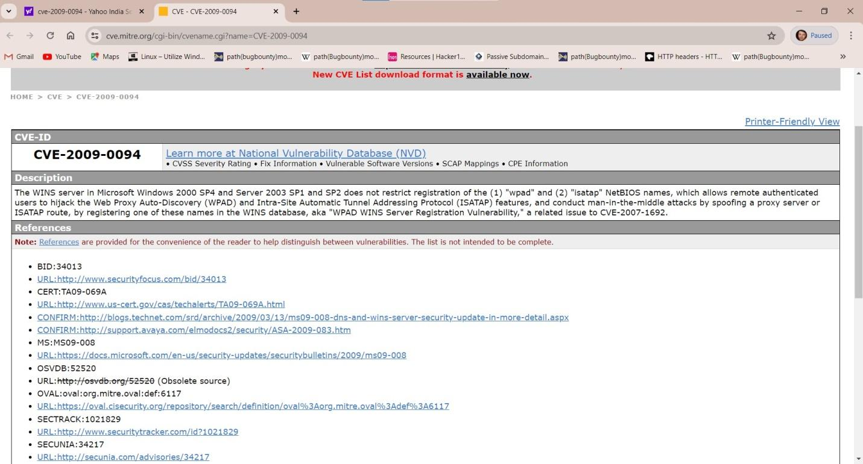

**CVE -2009-0094 windows XP/2007 netBIOS**

**Score is 7**

TASK 3:Identify whether the victim’s terminal is affected with MiMT attack or not and submit the incident report for the same.

This shows the forensics evidence of the samantha’s device to confirm weather her device was affected from MiTM attack or not, followed by the orchestration of the similar attack scenario represent through the changes generated in her arp table

**Note: In this demonstration we will use industry standard tools like Wireshark to capture the packets and arpspoof to spoof the mac address associated with the ip address in the arp table of the victim machine.**

Machine on the network with IP **10.0.2.3** and associated mac **08:00:27:60:79:08**

Victim machine IP is **10.0.2.15**

Attackers IP is 10.0.2.4 and the associated mac **08:00:27:50:4c:14**

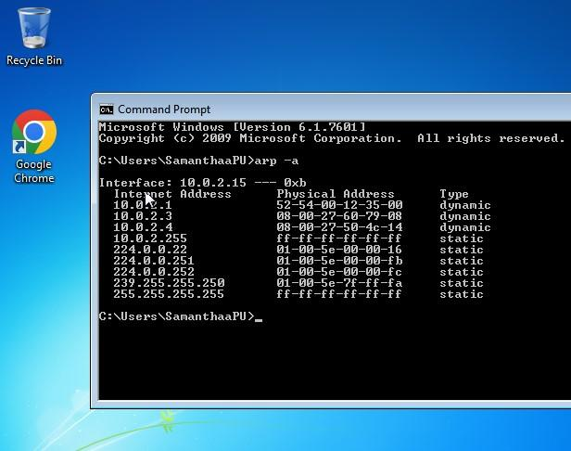

a) run the following command to turn on the ip forward and turn off the redirects

**$ sudo sysctl –w net.ipv4.ip_forward=1**

**$ sudo sysctl –w net.ipv6.cong.all.forwarding=1**

**$ sudo sysctl –w net.ipv4.conf.all.send_redirects=0**

**Below is the screenshot to demonstrate the same**

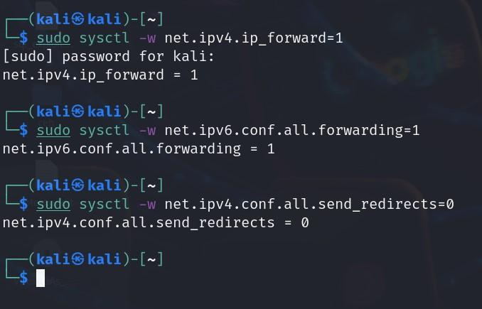

c) Now run the following command to spoof the mac address and execute the MiTM attack for demonstration

**$ sudo arpspoof –I eth0 –t 10.0.2.15 10.0.2.3**

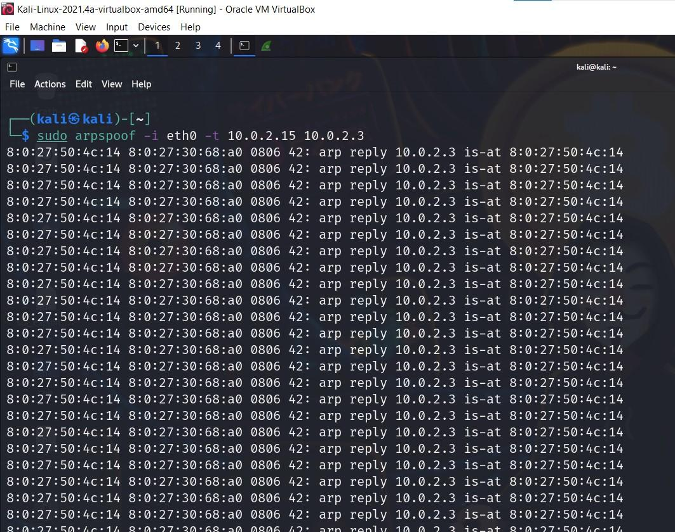

One can also examine the packets through wireshark:

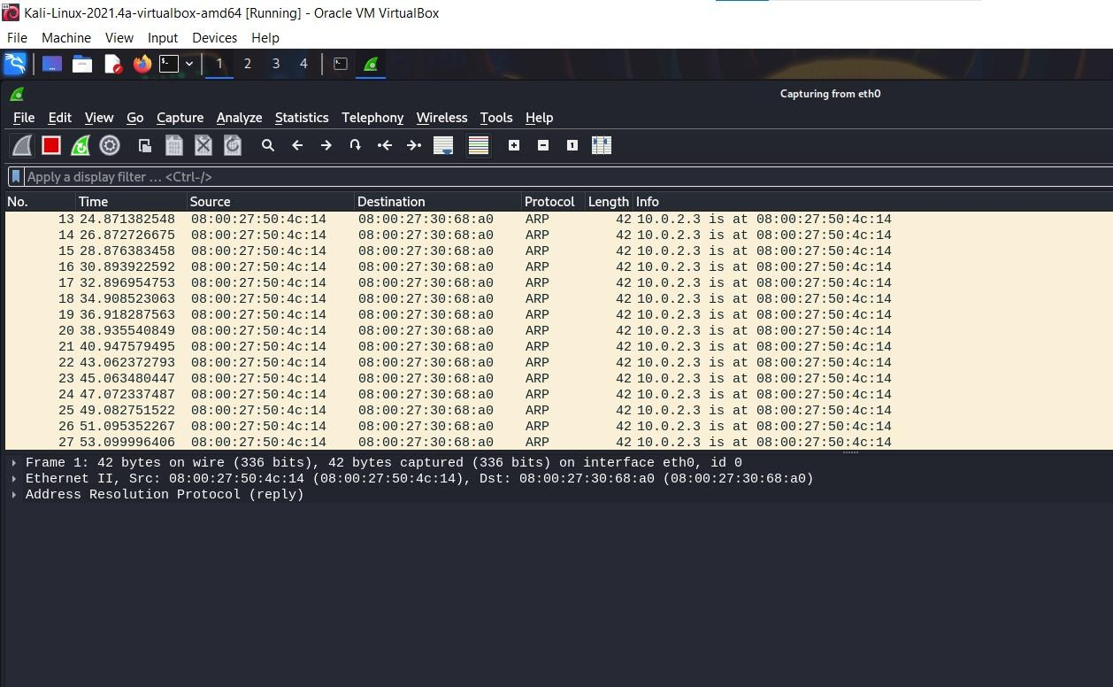

And finally we can see in the screenshot below that the mac address has been spoofed since both the IP of 10.0.2.3 and 10.0.2.4 has same mac address

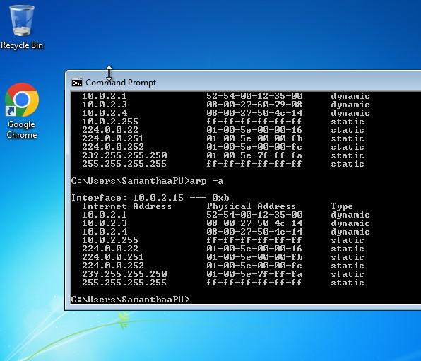

**Summary:**

* **Samantha was a victim of an MiMT attack type in which the following artifacts were used for compromising her personal email id**
* **Server IP is 10.0.2.4**
* **Victim IP is 10.0.2.15**
* **Total 1 terminal is connected with Server and Type of Operating system is Windows**
* **CVE -2009-0094 windows XP/2007 netBIOS**
* **Score is 7**
* **Default gateway IP is 10.0.2.2**
* **Victim Machine arp table shows the same mac address for two different ip addresses which means the packets meant to be sent to 10.0.2.3 are first sent to 10.0.2.15(man in the middle) during orchestration of the attack.**

**Since she is the victim of man in the middle attack which could have led to the compromise of her personal email ID further, the same email ID is used to send her abusive and threatening messages.**

TASK 4:Use email forensics analysis and identify the sender’s IP address

* **Go to the mailbox and click on the three dots option.**

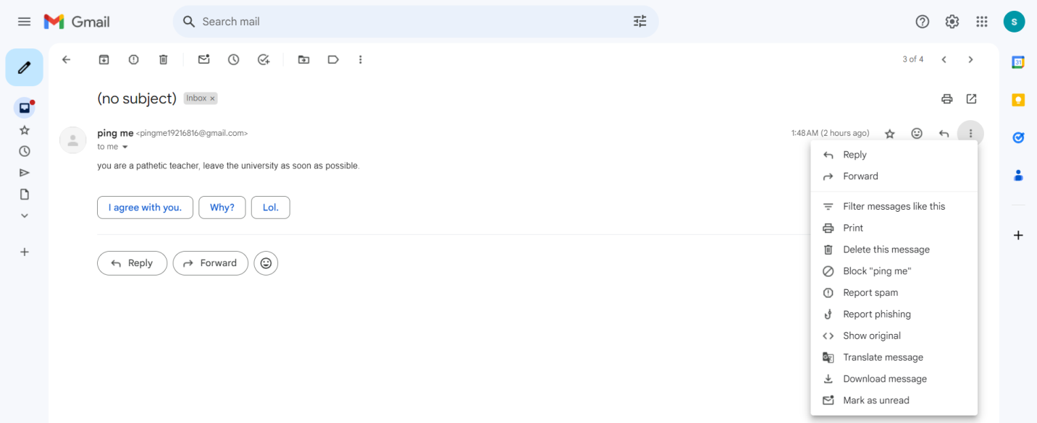

* **Click on Show original option.**

**It will show the original message with all the headers:**

Original Message

Message ID <CAHO4kB3XDG4YD-gag+K-0ecdnF32ZG_wctBcMkm4wSS8L513Xg@mail.gmail.com>

Created at: Tue, May 7, 2024 at 1:48 AM (Delivered after 13 seconds)

From: ping me <pingme19216816@gmail.com>

To: "samanthaa.collen.r@gmail.com" <samanthaa.collen.r@gmail.com>

Subject:

SPF: PASS with IP 209.85.220.41 Learn more

DKIM: 'PASS' with domain gmail.com Learn more

DMARC: 'PASS' Learn more

Download Original Copy to clipboard

Delivered-To: samanthaa.collen.r@gmail.com

Received: by 2002:a05:7022:32b:b0:7d:6ee5:a18f with SMTP id 43csp1571153dld;

Mon, 6 May 2024 13:18:43 -0700 (PDT)

X-Received: by 2002:a5d:4d52:0:b0:34e:81ab:463f with SMTP id a18-20020a5d4d52000000b0034e81ab463fmr570668wru.20.1715026723214;

Mon, 06 May 2024 13:18:43 -0700 (PDT)

ARC-Seal: i=1; a=rsa-sha256; t=1715026723; cv=none;

d=google.com; s=arc-20160816;

b=akCCB88AEkV6QR63J23SEYvTmx2C4RifWFsaCMCohmzqVOJ6yjm5uA4kVd/We8CAvm

XNFAcRcT2hZ02z0qsCkALI7tJawzOg/ZsUSgnntSmjSwWWcqA7uyQ0mVWgcqq4uz6mcm

hqF76rNKtl0foZ8SzZCX2gf4Y3u2zoLRgKxD9VgO7phtbE2SU6sYhuE74a4R0YlDSqfX

hsdm4gLuv0FEPo1knuOCN2EoNZoUGjclPH4DiP8eXtvQSCEIbUgKhD8rVYxj8rlyOVct

gf1Y4NMhAscANvCxRM5UDi7chEmTKGnLPWHellIwDUbt0RISC7iTUtIRyLVSP4x4imwP

228w==

ARC-Message-Signature: i=1; a=rsa-sha256; c=relaxed/relaxed; d=google.com; s=arc-20160816;

h=to:subject:message-id:date:from:mime-version:dkim-signature;

bh=iTWDAuur3aOI9gyiOElxslQ7VKIu4JYTF5zPtE2EpP8=;

fh=iWBLuz8abCZqBLdaU9AJjjBYNAoXiX+6vFZJJLqPRvY=;

b=NWoHiMpjt+wsxUrQb/wrT6U/y4sSFRPdXRq36jYHWt+7YuWAqHPPcxmR4LudfBjvG7

VFLuMgbe/OxZXlv67uHKT8xG0uAVcOChke4Y1TO7Dkno8zZ1yILRDaGRjxnAfJjHrKqI

0rAja07XaINu8/Qo578ttVcx0iDgVeepzAD4uj3cdw9w9ue6HKAOCd8GevVcsUM3c3LD

BOb+1E7ie0eh6gSD42jJUEaOCAXq1tNY6aaSi4uTHLSZBp/o8qNY7WPJGkP8wjjNr5k+

cuf0SxVlBr1XyRkfjBIaPrJm10z7TqN16B+R7kNE+AG7zlwfZKwqdypSXFA9vcWei1ZS

NkdQ==;

dara=google.com

ARC-Authentication-Results: i=1; mx.google.com;

dkim=pass header.i=@gmail.com header.s=20230601 header.b=KwAPtKkP;

spf=pass (google.com: domain of pingme19216816@gmail.com designates 209.85.220.41 as permitted sender) smtp.mailfrom=pingme19216816@gmail.com;

dmarc=pass (p=NONE sp=QUARANTINE dis=NONE) header.from=gmail.com

Return-Path: <pingme19216816@gmail.com>

Received: from mail-sor-f41.google.com (mail-sor-f41.google.com. [209.85.220.41])

by mx.google.com with SMTPS id v13-20020a5d610d000000b0034e54870505sor2226297wrt.1.2024.05.06.13.18.43

for <samanthaa.collen.r@gmail.com>

(Google Transport Security);

Mon, 06 May 2024 13:18:43 -0700 (PDT)

Received-SPF: pass (google.com: domain of pingme19216816@gmail.com designates 209.85.220.41 as permitted sender) client-ip=209.85.220.41;

Authentication-Results: mx.google.com;

dkim=pass header.i=@gmail.com header.s=20230601 header.b=KwAPtKkP;

spf=pass (google.com: domain of pingme19216816@gmail.com designates 209.85.220.41 as permitted sender) smtp.mailfrom=pingme19216816@gmail.com;

dmarc=pass (p=NONE sp=QUARANTINE dis=NONE) header.from=gmail.com

DKIM-Signature: v=1; a=rsa-sha256; c=relaxed/relaxed;

d=gmail.com; s=20230601; t=1715026722; x=1715631522; dara=google.com;

h=to:subject:message-id:date:from:mime-version:from:to:cc:subject

:date:message-id:reply-to;

bh=iTWDAuur3aOI9gyiOElxslQ7VKIu4JYTF5zPtE2EpP8=;

b=KwAPtKkP+j4j3IWHopHxwrx7dBqdASxgB7nSQfaxXOeKpSjpNs7FtkaH+mcumRWaR0

2QvZ3npe6yOdVF3C7vAOQunV51yrHD7foOqdJeh8XN/k2rQfTCUoLRtM9WBXgS3FyS3O

ew1cR4WKnVrzGlRyLnSpyk/XYd77WmesVPbNeZbN3H23wHQm+8tJ4BQ6gRbvl8Vigo/o

0pmq/rcajxLhi4KfALi6l4b6OAhkufAycVcuDdtDyWPhi3QwArxF2cAmT6kYeUHeN1zc

LO9Ylsa/zEjCKUrftapxzDjigegk+Jb3dUlmhUTu9arhw/KzB8XEshIAUIWqUEx3q4P5

sX1w==

X-Google-DKIM-Signature: v=1; a=rsa-sha256; c=relaxed/relaxed;

d=1e100.net; s=20230601; t=1715026722; x=1715631522;

h=to:subject:message-id:date:from:mime-version:x-gm-message-state

:from:to:cc:subject:date:message-id:reply-to;

bh=iTWDAuur3aOI9gyiOElxslQ7VKIu4JYTF5zPtE2EpP8=;

b=nuTy5eQYCeETN+un1uwLWwx6op6FB53h99/ClmA5vX9QxKdSMtwKoX4kuTJQaxEAAx

Uf8AN+rc5CA8st5hWVBmLBe1dapusnDufr+caCQpvHJXimGpgWpq/87LusPElLuJmyTb

sAZptfE2ljsr+UL8tPxhVwhiH4kb+FTd0F11mWryVpkOErD27DU2qZNw4BkbvyAAj/yd

bUj4WCjZFFlmab9FnAFZWgpF+FbSFndpYcYJsobkEtg2Z4M+0U0xOTHg4EJoaOhWfwIg

Q4AHLA+FOm/m52teGZ71nqX0SjOEiu/5ZsKcGkd6pXvvm0d7IQ/3eRXNp3yQ98r/DqB/

/evQ==

X-Gm-Message-State: AOJu0Yx8WZ0wpqYiRcwqtmVBBVM5VYFNTaLNrfXoV+zy9pr9haGRsH8n eDzI/QSDiEjyzHSYdZafJPSZ1aGvaHAgyMZHqcF/5pHT9NfX4wftybAXYeq4aFzgoGGf4t0rBqF Qa7JwNJpzo4bTAWdErV2U3W1FBe9zqwuY

X-Google-Smtp-Source: AGHT+IGP1ERZFSecmUFaKNvaVU2jc1f25/L5MIN8I2KJo1Dr6gm2iUaXhEBBjB38FLobxldG21sIONV053dTO6WryWA=

X-Received: by 2002:a5d:4a02:0:b0:34d:ab1a:6384 with SMTP id m2-20020a5d4a02000000b0034dab1a6384mr550682wrq.13.1715026722252; Mon, 06 May 2024 13:18:42 -0700 (PDT)

MIME-Version: 1.0

From: ping me <pingme19216816@gmail.com>

Date: Tue, 7 May 2024 01:48:30 +0530

Message-ID: <CAHO4kB3XDG4YD-gag+K-0ecdnF32ZG_wctBcMkm4wSS8L513Xg@mail.gmail.com>

Subject:

To: "samanthaa.collen.r@gmail.com" <samanthaa.collen.r@gmail.com>

Content-Type: multipart/alternative; boundary="0000000000008f6d740617cec640"

--0000000000008f6d740617cec640

Content-Type: text/plain; charset="UTF-8"

you are a pathetic teacher, leave the university as soon as possible.

--0000000000008f6d740617cec640

Content-Type: text/html; charset="UTF-8"

<div dir="auto">you are a pathetic teacher, leave the university as soon as possible.</div>

--0000000000008f6d740617cec640--

* **Executing forensics on email and we can clearly see the ‘Received’ headers. The last ‘Received’ header is corresponding the first event of transmition of email from the** **MUA(Mail user agent) to MTA(mail transfer agent) based on the SPF(Sender Policy Framework) hence the client IP is 209.85.220.41(highlited in red color within the original email)**
* **Using the IP and any online tool available to trace the geolocation of the IP we can find the location of the attackers email server**

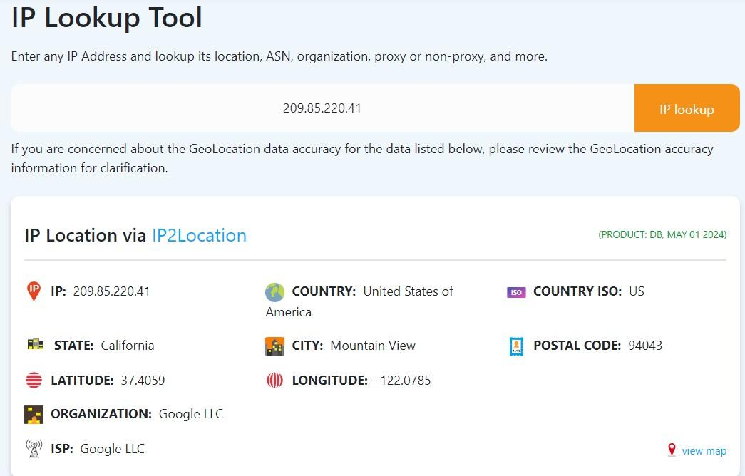

TASK 5:Submit the complete incidence report

**Incident Description:**

|  |  |
| --- | --- |
| **Threat Description** | Credential hijacking using Man-in-the-Middle attack(Attack on the confidentiality) |
| **Threat Target** | Samantha(Faculty of the University) |
| **Attack Techniques** | Man-in-the-Middle Attack (MiMT) through exploitation of cofiguration flaws of the victim system. |
| **Controls/**  **Countermeasures** | Scanning the device, Banner grabbing and identifying vulnerable ports and services |
| **Artifact Hijacked** | Personal email ID of victim ( samantha.collen.r@gmail.com) |
| **Threat Statement** | C:\Users\LENOVO\Pictures\Screenshots\Screenshot (891).png |
| **Collected Artifacts From Incident Response Team Other Collected Artifacts** | **Server IP is 10.0.2.4**  **Victim IP is 10.0.2.15**  Total 1 terminal is connected with Server and Type of Operating system is Windows  CVE -2009-0094 windows XP/2007 netBIOS  Score is 7  Default gateway IP is 10.0.2.2  Victim Machine arp table shows same mac address for two different ip address which means the packets ment to be sent to 10.0.2.3 are first sent to 10.0.2.15(man in the middle) during orchestration of the attack.  Since she is the victim of man in the middle attack which could have lead to the compromise of her personal email ID further same email ID is used to send her abusive and threatening messages. |
| **Attacker Email Summary** | **Email forensic analysis with original source:**  **C:\Users\LENOVO\OneDrive\Pictures\Saved Pictures\ss21.jpg** |
| **E-Mail Forensic Summary** | **C:\Users\LENOVO\OneDrive\Pictures\Saved Pictures\ss20.jpg** |